Improving Deep Neural Networks: Hyperparameter Tuning, Regularization and Optimization

Table of Contents

Practical Aspects of Deep Learning 2

Train/Dev/Test split 2

Basic Recipe for Machine Learning 7

Common Definitions Used in Deep Learning 7

Regularization 7

Why Regularization Reduces Overfitting? 8

Dropout Regularization 9

Other Regularization Methods 11

Normalize Inputs 12

Vanishing/Exploding Gradients 12

Weight initialization 13

Numerical Approximation of Gradients 15

Gradient checking 16

Optimization Algorithms 16

Mini-batch Gradient Descent 16

Exponentially Weighted Average (EWA) for optimization 18

Gradient Descent with Momentum 18

RMSprop (root mean square prop) 20

Adam (adaptive moment estimation) Optimization Algorithm 21

Learning rate decay 23

The problem of local minima 23

Hyperparameter tuning, Batch Normalization and Programming Frameworks 24

Tuning process 24

Using Appropriate Scales for Hyperparameter Search 24

Hyperparameter Tuning in Practice: Pandas vs. Caviar 25

Batch normalization 26

Softmax Regression 29

Deeplearning framework 30

Tensorflow 31

# Practical Aspects of Deep Learning

## Train/Dev/Test split

1. Purpose of train/dev/test data

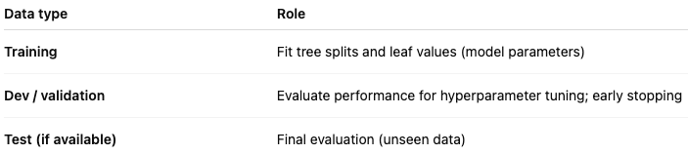

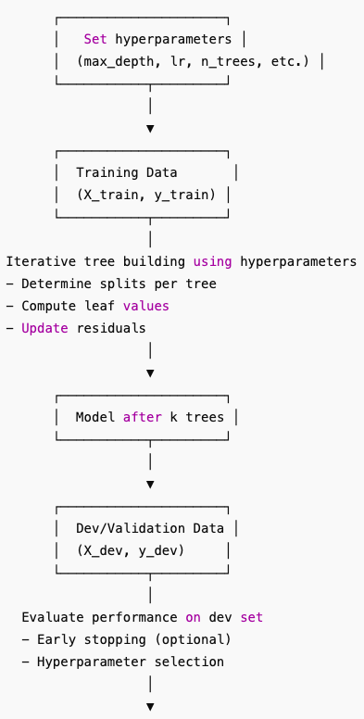

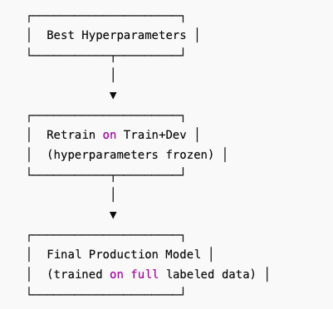

Is retraining necessary: Retraining is optional but often recommended if you want the final model to leverage all labeled data without changing hyperparameters. If your training set is already large and representative, you can skip it.

How to tell whether the training set is representative of the production data:

* Training set should cover all types of inputs the model will see in production.
* Avoid datasets that are too old, biased, or limited to a small segment of users.
* If unsure, retraining with additional labeled data (dev + train) is a safe choice.

1. Data leakage: Any action where information from the target or unseen dataset influences model parameters, feature engineering, or preprocessing is data leakage.

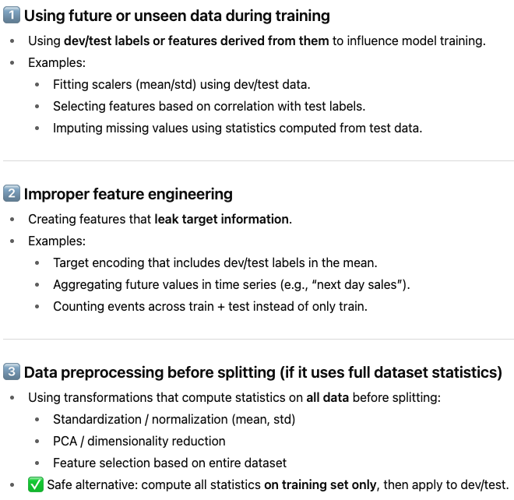

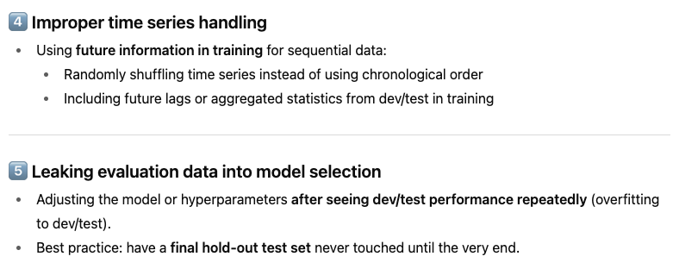

Example for time series data:

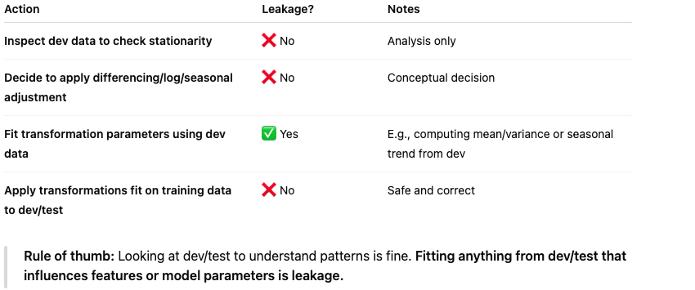

1. Proportion of train/dev/test

* When your dataset is small, such as 100-10000 datapoints, we can do 60%/20%/20%.
* However, when we have a larger dataset, say 1,000,000. We don’t need to split this way. We can use most data for training and leave small portion for dev and test, because the goal of the dev set is to test different algorithms on it and see which algorithm works better and the dev set just needs to be big enough to evaluate different algorithm choices. In this case, we can just use 10000 points as the dev and test sets, respectively. The ratio for train/dev/test in this case is 98%/1%/1%. We just need to ensure the dev and test sets are representative.
* How to judge if the dev and test sets are representative enough to evaluate your model before production:

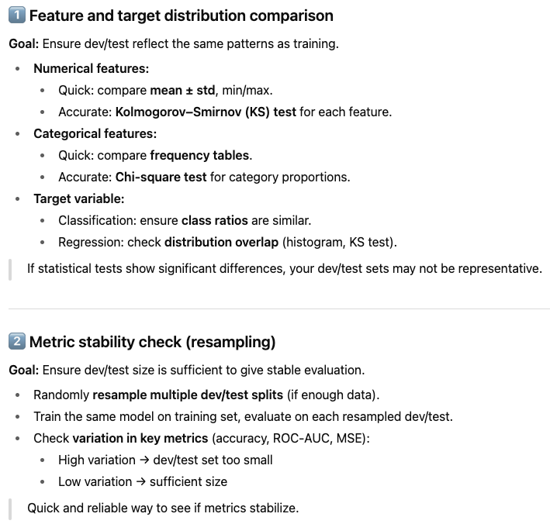

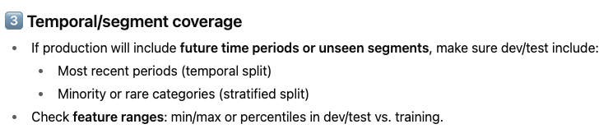

* The goal of the test set is to give you an unbiased estimate of the performance of the final network. But if you don’t need that unbiased estimate, then we can only use training data to train models and evaluate those models on the dev datasets.

1. Mismatched train/test distributions:

* Rule of thumb: always ensure they follow the same distribution because we will use the dev set to evaluate models, it's nice if your dev set comes from the same distribution as your test set.
* But because deep learning algorithms have such a huge hunger for training data 🡪 training set might not come from the same distributions as dev/test.
* Example that train and test sets have different distributions: Training set is cat pictures from webpage, which are very clear and nicely framed pictures. But the dev/test sets are cat pictures from users using your app, which may be blurrier and have lower resolution and taken with cellphone camera in a more casual condition.

1. Whether to split data before or after feature transformation:

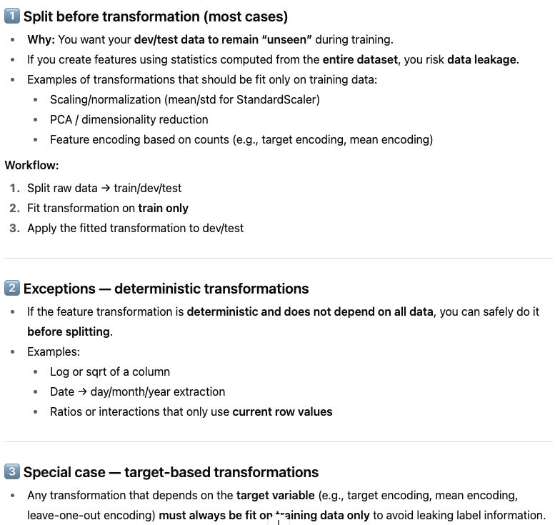

## Basic Recipe for Machine Learning

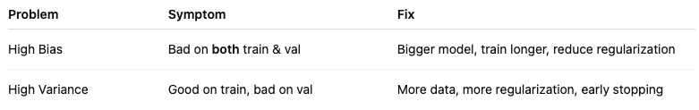

## Common Definitions Used in Deep Learning

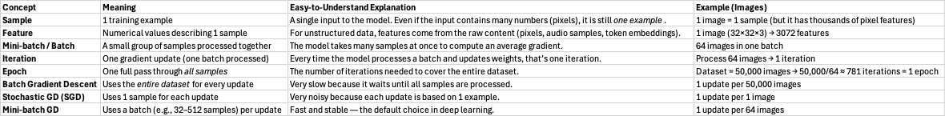

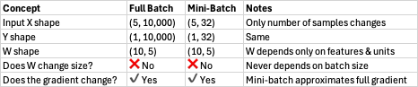

## Regularization

For logistic regression:

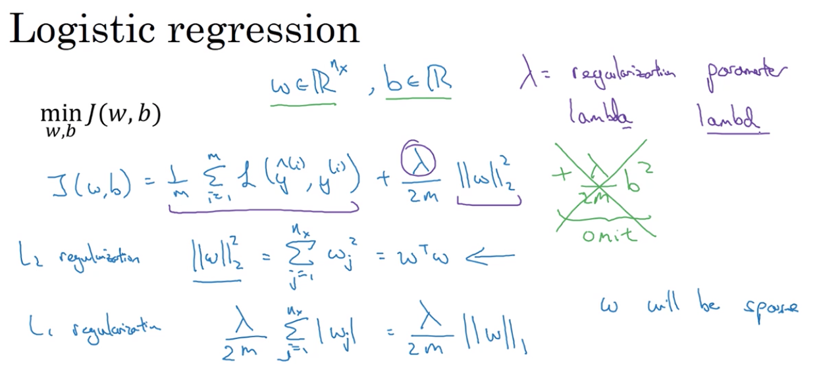

* L1 regularization drives some weights exactly to zero, which creates a sparse model (many weights become zero). In theory, this can reduce memory usage because zero weights can be skipped or compressed. However, in practice the savings are usually minimal, so L1 is rarely used for model compression in deep learning.
* L2 regularization shrinks weights toward zero without setting them exactly to zero, which leads to smoother gradients and more stable training. This makes L2 a better fit for neural networks, so it is used far more often than L1.

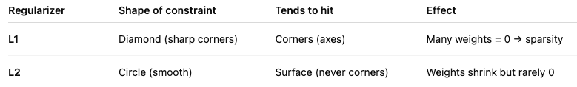

* λ (lambda) is the regularization parameter that controls how strongly the model penalizes large weights. It’s treated as a hyperparameter and is usually tuned using a development set or cross-validation to balance fitting the training data with preventing overfitting.

For neural network: the regularization part is in Frobenius form **(take every entry in the matrix, square it, sum them all, then take the square root** — very similar to the Euclidean (L2) norm, but extended to matrices). Adding regularization 🡪 extra terms in the gradients wrt weight matrices

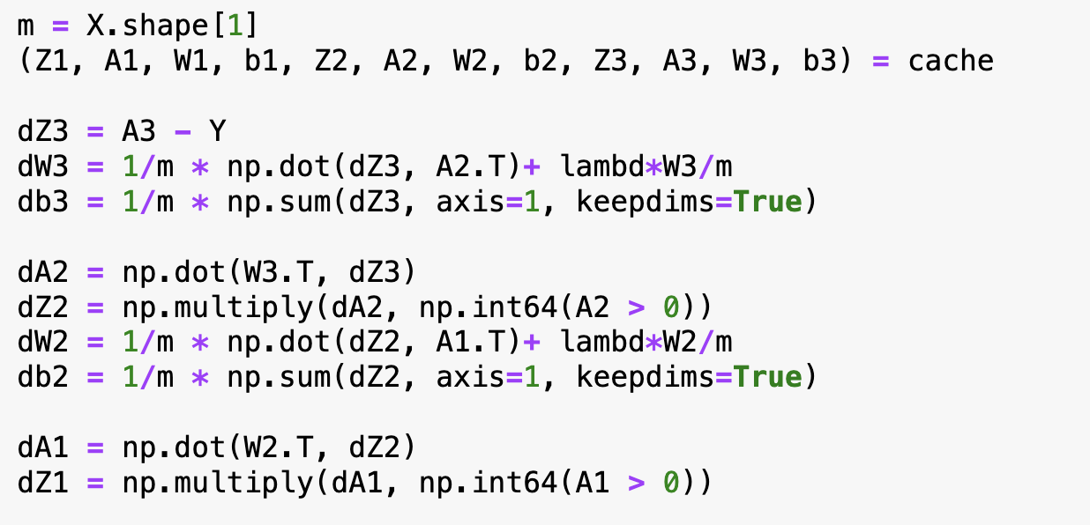

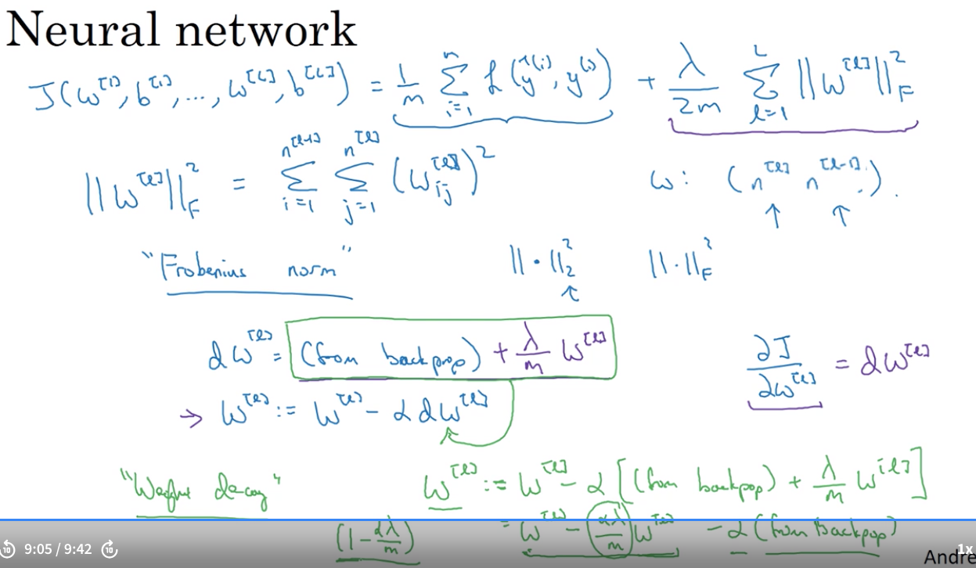

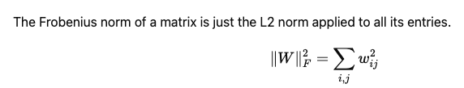

## Why Regularization Reduces Overfitting?

* If we make regularization lambda to be very big, then weight matrices will be set to be reasonably close to zero, effectively zeroing out a lot of the impact of the hidden units. Then the simplified neural network becomes a much smaller neural network, eventually almost like a logistic regression. We’ll end up with a much smaller network that is therefore less prone to overfitting.
* Taking activation function g(Z)=tanh(Z) as example, if lambda is large, then weights W are small and subsequently Z ends up taking relatively small values, where g and Z will be roughly linear which is not able to fit those very complicated decision boundary, i.e., less able to overfit.

## Dropout Regularization

* Batch-based training: A batch is the small subset of training data that the model processes in a single forward-and-backward pass before updating its weights. It helps with faster computation, stable gradients, and memory efficiency (Makes use of parallel computation on GPUs).

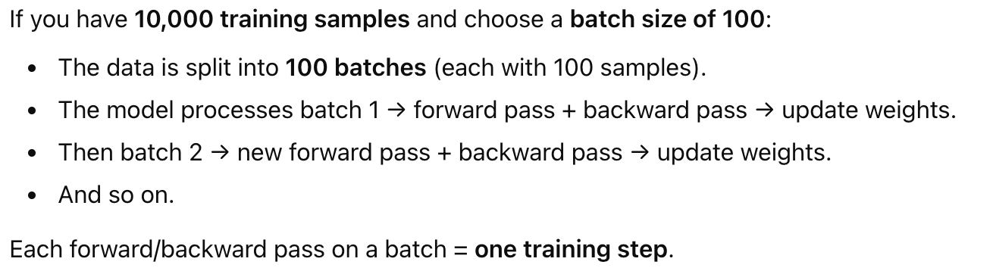

Visualization for batch-based training:

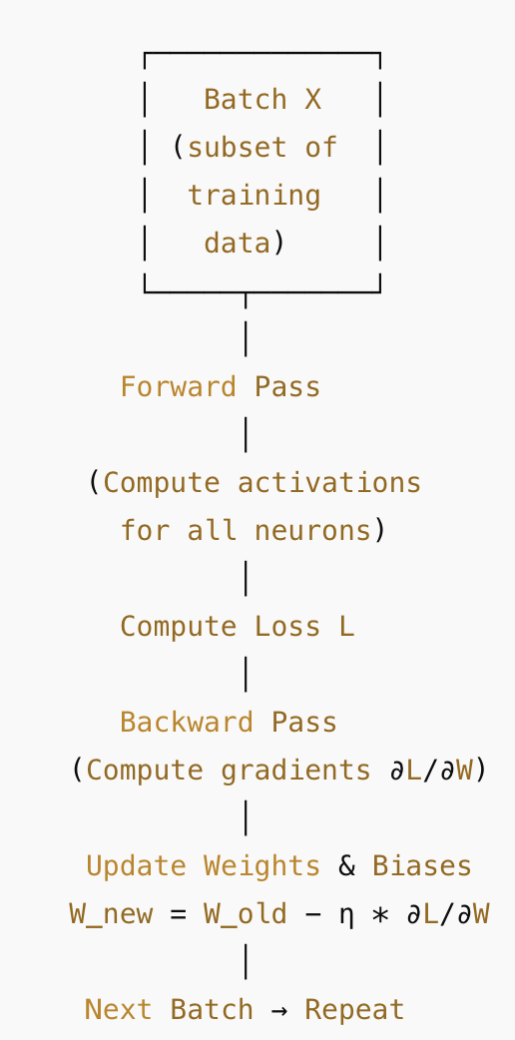

* + Dropout: Applied here per batch → random neurons temporarily deactivated.
  + Batch size: Number of examples processed per step.
  + Epoch: One pass over the entire dataset (all batches). Training typically involves **multiple epochs** for convergence.
  + Weights converge over many batches and epochs to minimize overall loss.
* Dropout:
  + Dropout is to set some probability and eliminate the node in the NN. E.g. In the plot below, red cross shows the nodes that are eliminated.
  + It is designed to work with batch-based training.
  + Applied **per batch**, with a new random mask for each batch.
  + Forces network to learn **robust, redundant representations**. Dropout prevents over-reliance on any single feature by randomly deactivating neurons during training, which spreads out weights and effectively shrinks their squared norm—similar to L2 regularization—helping reduce overfitting. 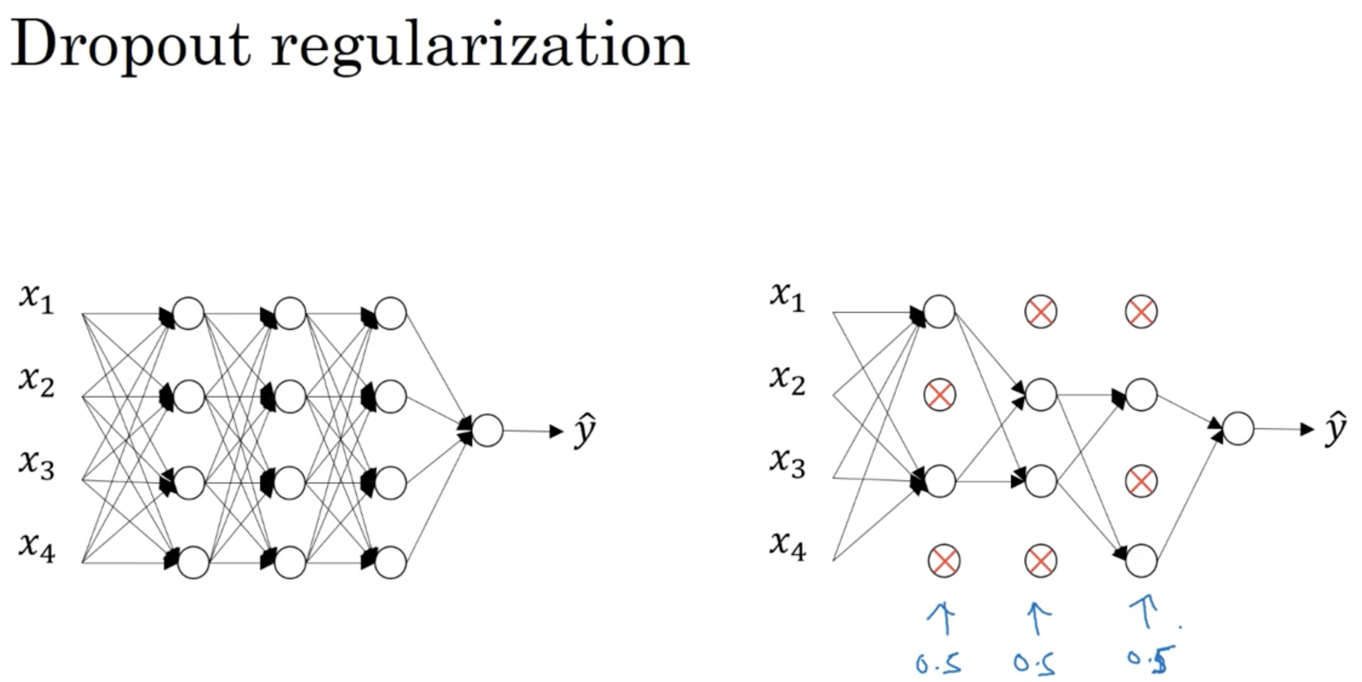
* Inverted dropout: Inverted dropout multiplies surviving neurons by 1/(1−p) during training to keep the expected activation consistent between training and inference. This is necessary because dropout randomly sets a fraction p of neurons to 0 during training, reducing total activation; without scaling, the network would see different activation levels at inference, slowing learning or destabilizing gradients.
* Implementation tips:
  + Layers with many parameters are most prone to overfitting; applying a smaller keep probability (more aggressive dropout) is recommended for these layers.
  + Drawback: introduces extra hyperparameters, which may require cross-validation to tune.
  + Common in computer vision, where large inputs (e.g., images) make overfitting likely.
  + Using dropout can make the cost function (J) noisier and harder to monitor. Best practice: verify the model works without dropout first, then enable dropout.
  + Apply dropout only during training—not during inference/testing.
  + Deep learning frameworks (TensorFlow, Keras, PaddlePaddle, Caffe) provide built-in dropout layers.
  + Code: 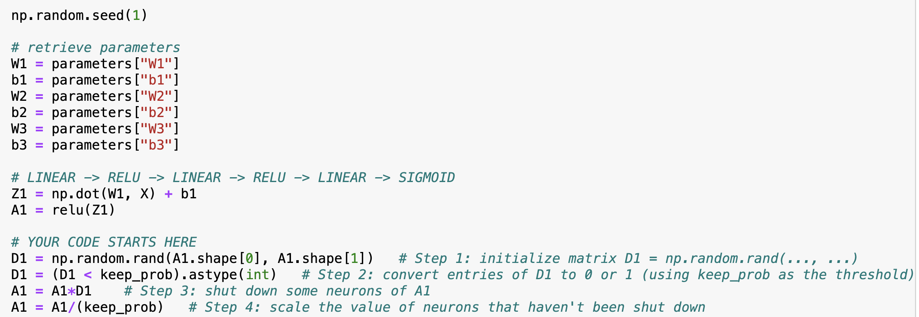

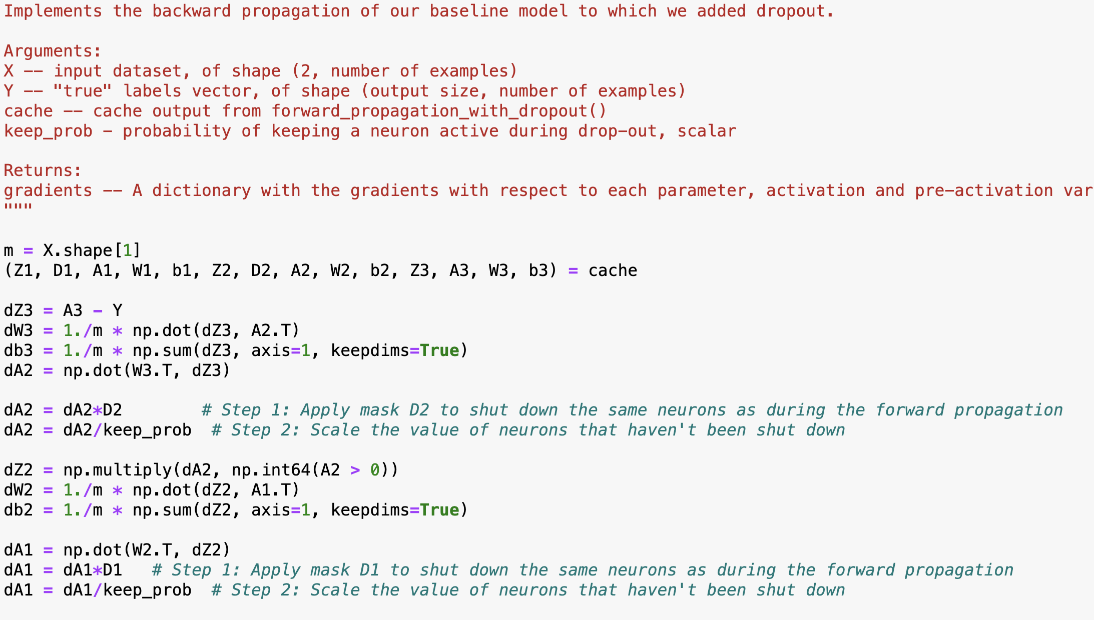

## Other Regularization Methods

**Method 1 Data Augmentation:** Creates additional “fake” training examples when real data is limited by applying transformations like horizontal flipping, random cropping, distortion, or translation.

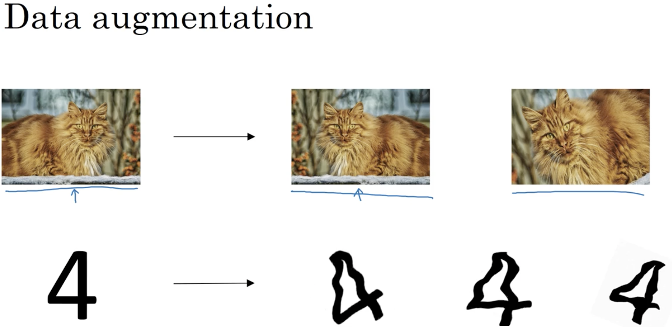

**Method 2 Early Stopping:** Stops training before full convergence to get intermediate-sized weights.

* **Advantage:** Allows exploring small, medium, and large weight magnitudes (and thus model complexity) without explicitly tuning L2 regularization (λ).

Weight magnitudes naturally grow as training progresses. Weight size is influenced by:

1. learning rate (higher → faster weight changes),
2. number of training steps (more steps → larger weights),
3. regularization strength (larger λ → smaller weights), and
4. early stopping (fewer steps → indirectly limits weight growth).

* **Disadvantage:** early stopping mixes two different goals into one decision—optimizing the cost function J (train long enough so the model fits the data well) and preventing overfitting (keep weights from becoming too large so the model generalizes) —that are ideally separate, adding complexity.

## Normalize Inputs

With normalization, cost function will be more round and easier to optimize when features are all on similar scales.

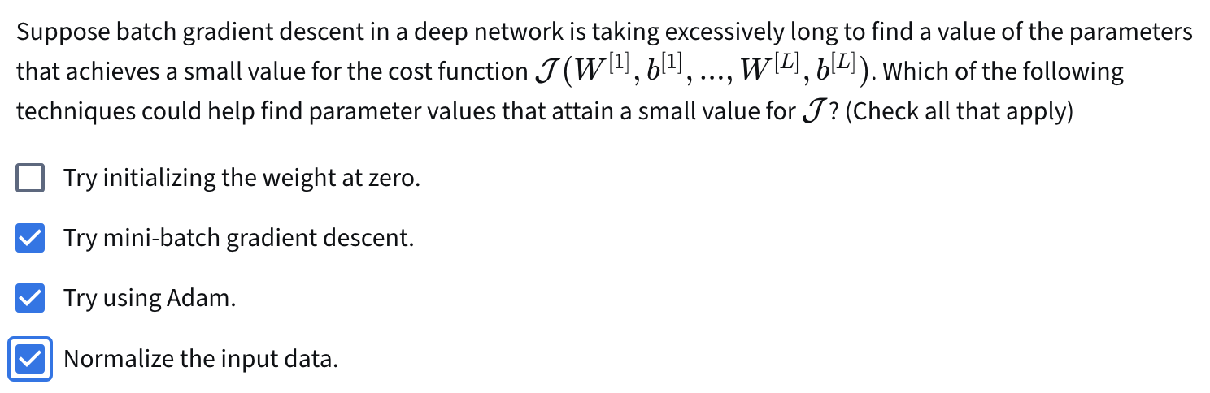

## Vanishing/Exploding Gradients

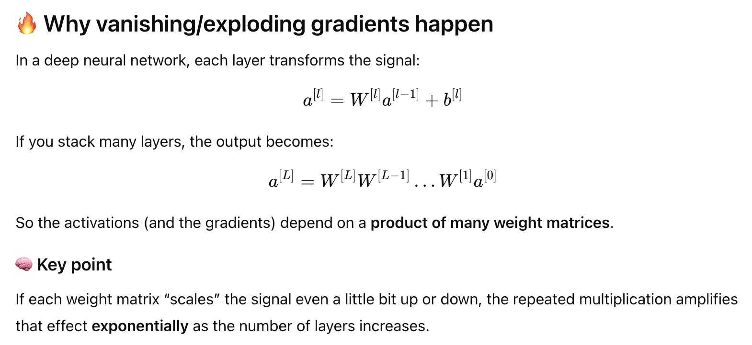

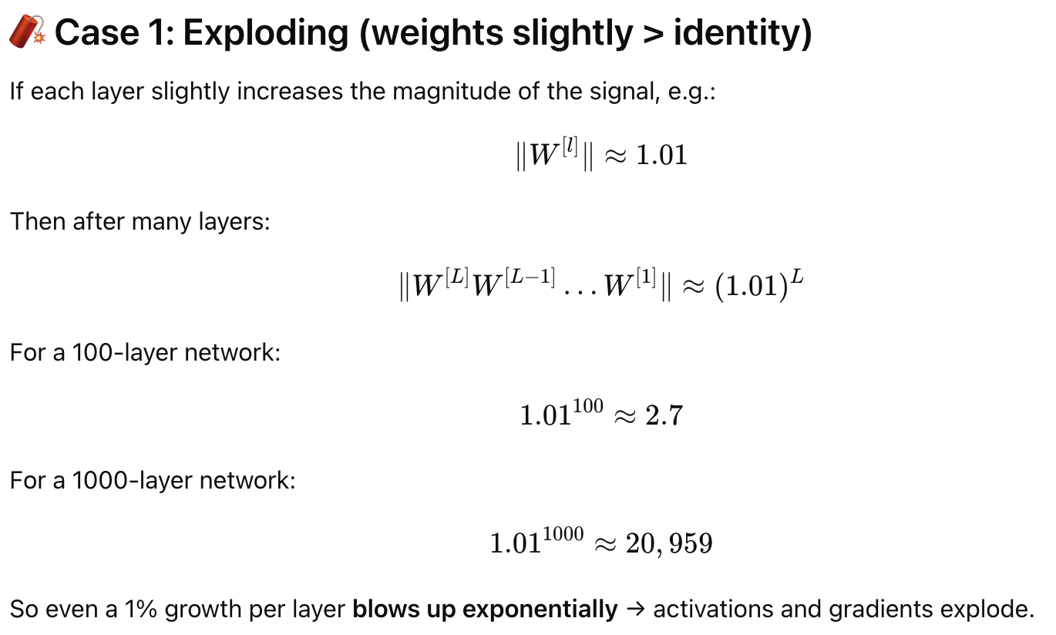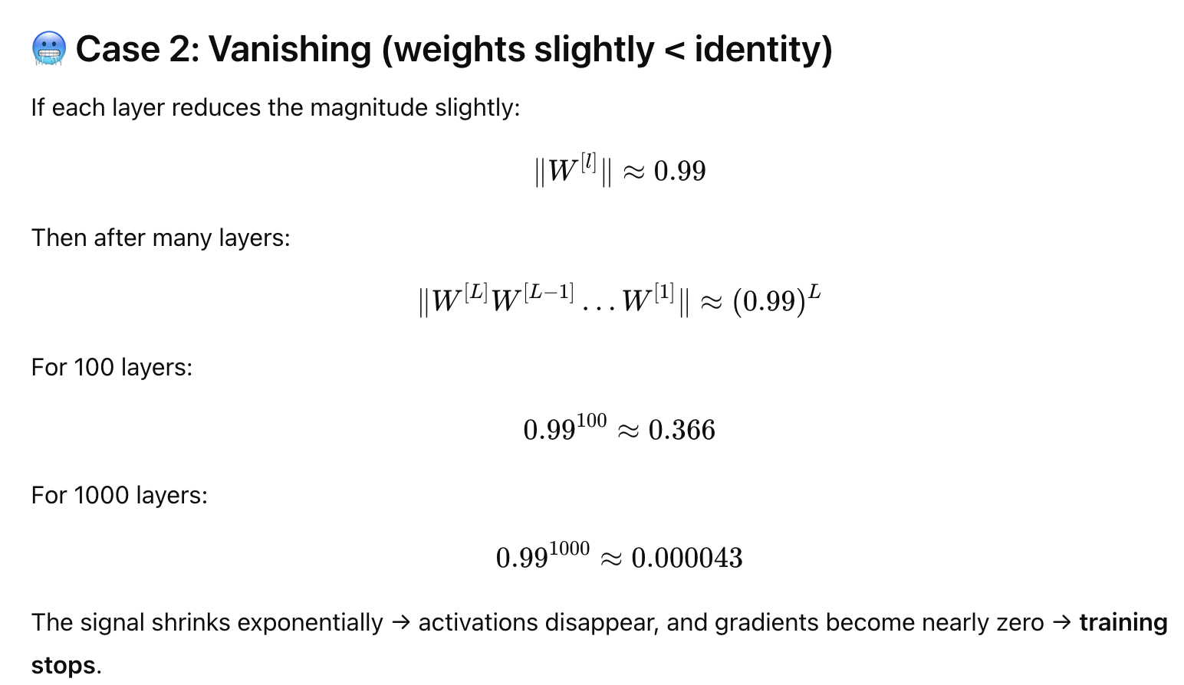

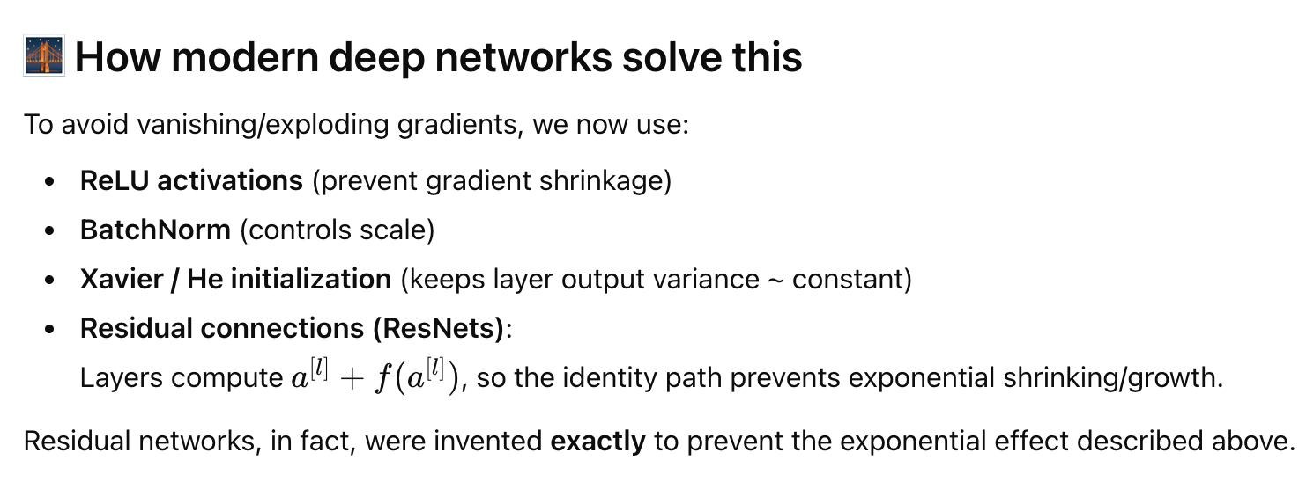

ReLU does not fix exploding gradients, but it greatly reduces vanishing because:

* When the neuron is active, its derivative = 1
* Multiplying by 1 does not reduce gradient magnitude
* Sigmoid/tanh multiply by <0.3 repeatedly → gradients get tiny exponentially

## Weight initialization

1. Why initialization matters:

* Speeds up gradient descent convergence
* Increases chances of reaching lower training and generalization error

1. Core principal:

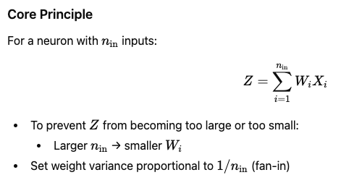

1. Standard initialization methods:

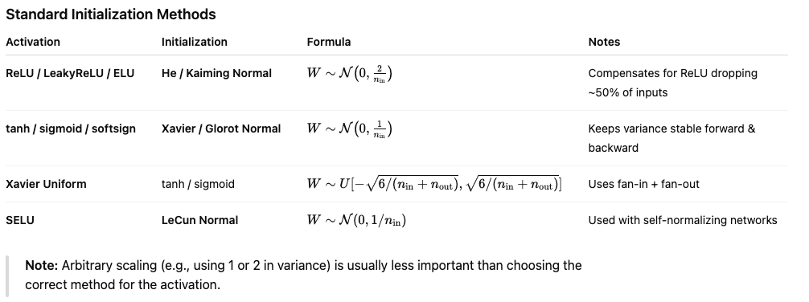

1. Implementation tips

* Weights must be random → breaks symmetry, allowing different neurons to learn different features
* Biases can be initialized to zero
* Do not use very large random weights → causes exploding gradients
* Small random values alone are insufficient → use He/Xavier instead
* He initialization works well with ReLU activations; Xavier works well with tanh/sigmoid

1. Python Example

import numpy as np

# He initialization for layer l with ReLU

W[l] = np.random.randn(shape) * np.sqrt(2 / n[l-1])

# Xavier initialization for tanh

W[l] = np.random.randn(shape) * np.sqrt(1 / n[l-1])

## Numerical Approximation of Gradients

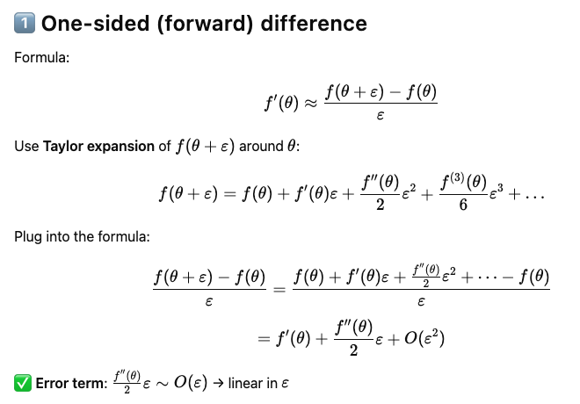

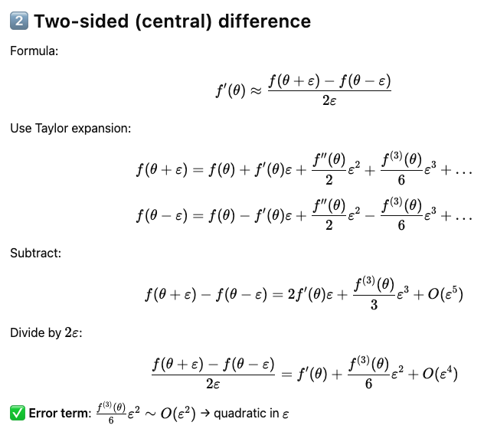

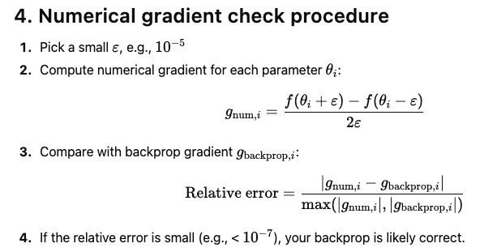

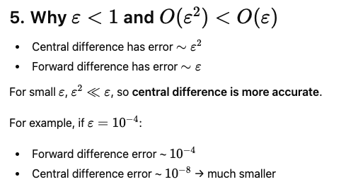

## Gradient checking

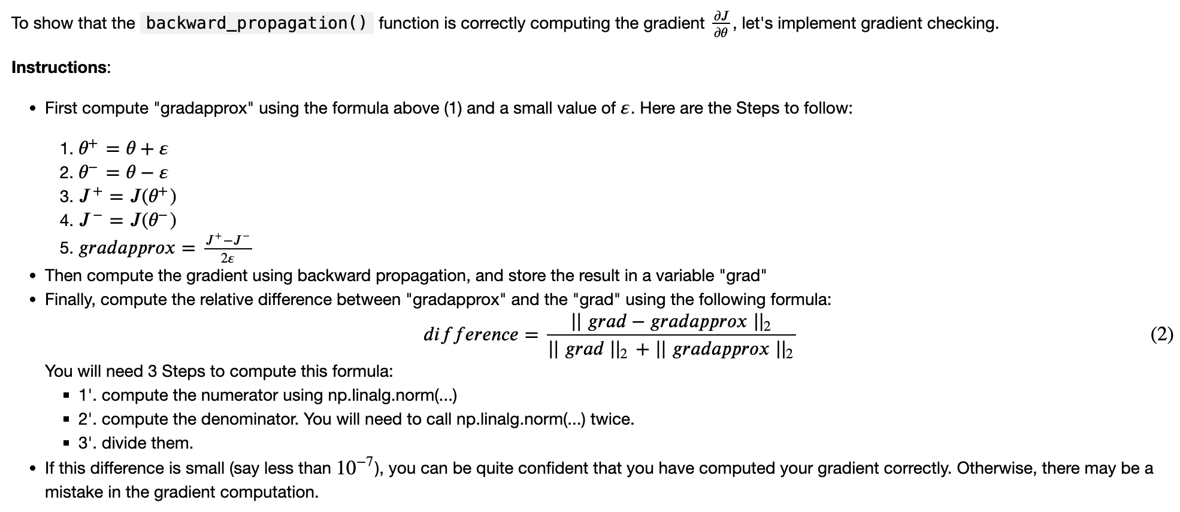

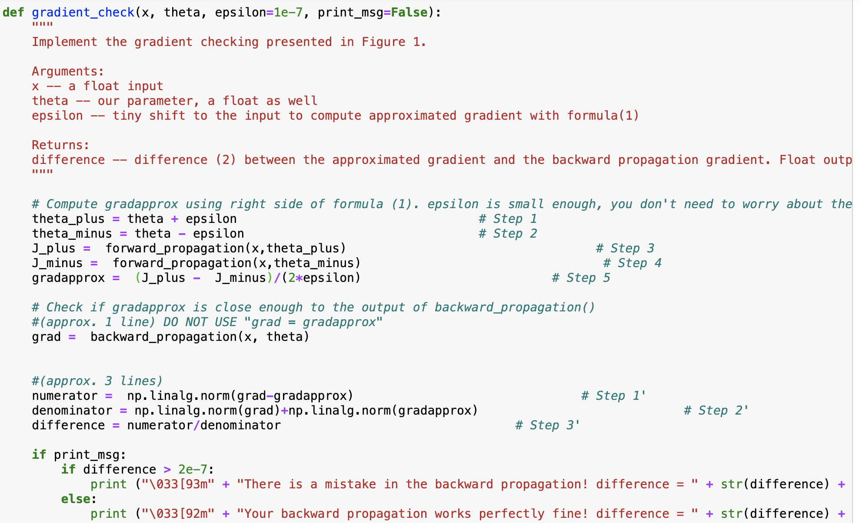

# Optimization Algorithms

## Mini-batch Gradient Descent

1. Why: Mini-batch gradient descent works much faster in the large datasets.
2. Notation of mini-batches: sample size = 5,000,000. 5000 mini-batches of 1000 each, then the notation will be like:

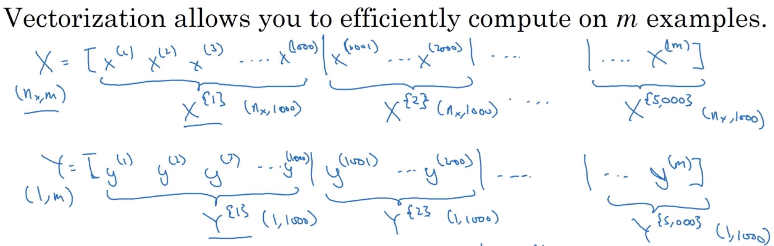

In general, 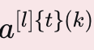 denotes the activation of the layer l*l*l when the input is the example k from the mini-batch t.

1. Forward and backward propagation for mini-batch training:

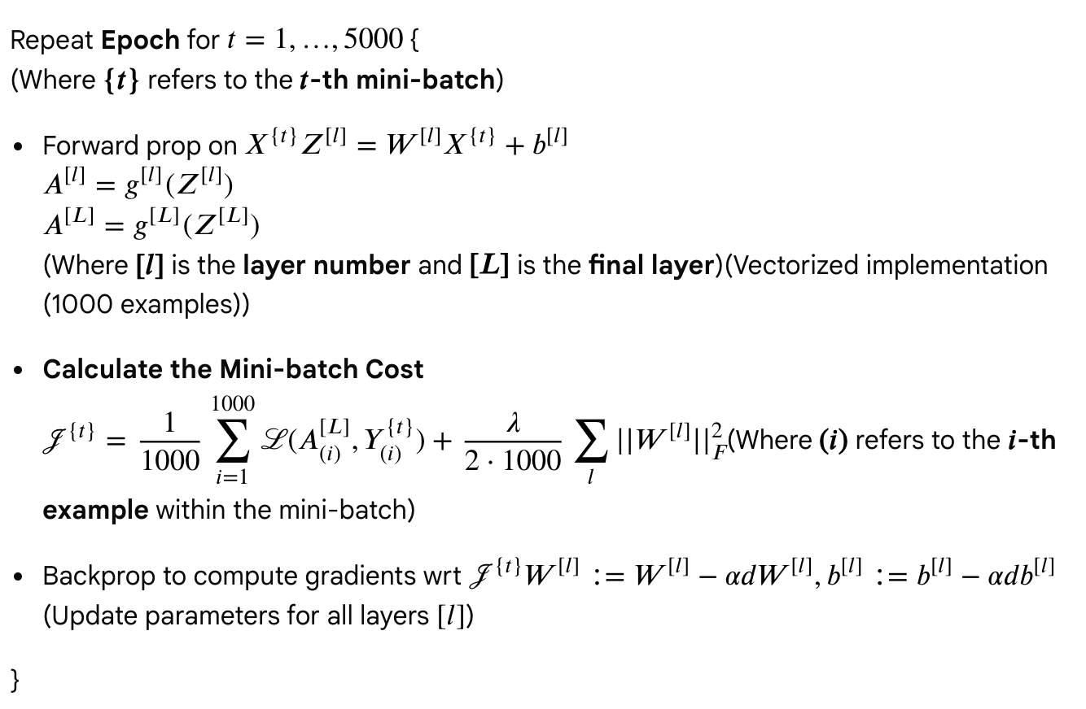

1. Comparison for three gradient descent methods

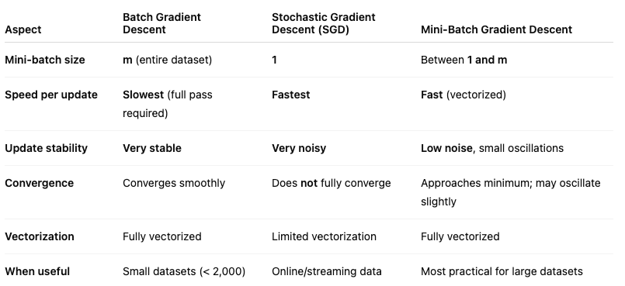

1. For mini-batch gradient descent, how to choose the mini batch size

* It has to be a power of 2 (because of the way computer memory is layed out and accessed, sometimes your code runs faster if your mini-batch size is a power of 2): 64, 128, 256, 512, 1024, ...
* Make sure that mini-batch fits in CPU/GPU memory .

1. Shuffling (ensures that examples will be split randomly into different mini-batches) and partitioning are the two steps required to build mini-batches

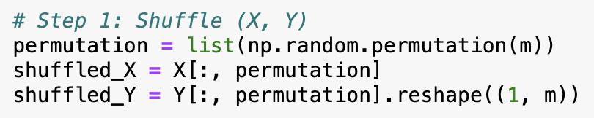

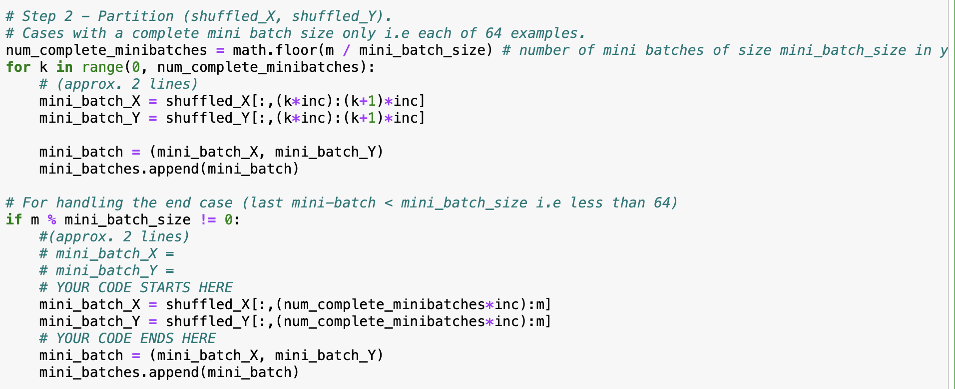

## Exponentially Weighted Average (EWA) for optimization

1. Notation: v(t) = beta * v(t-1) + (1-beta) * theta(t)
2. Bias correction in EWA: common beta value = 0.9

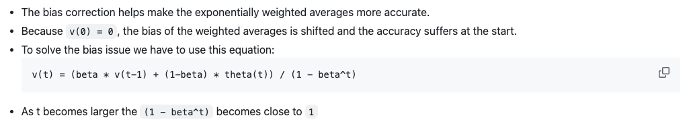

1. Intuition: The reason why EWA is useful for further optimizing gradient descent algorithm is that

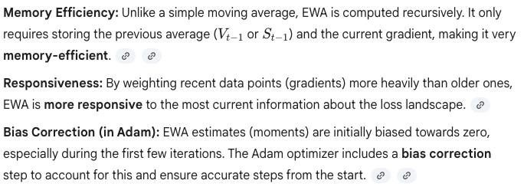

## Gradient Descent with Momentum

* Formula for gradient descent with momentum

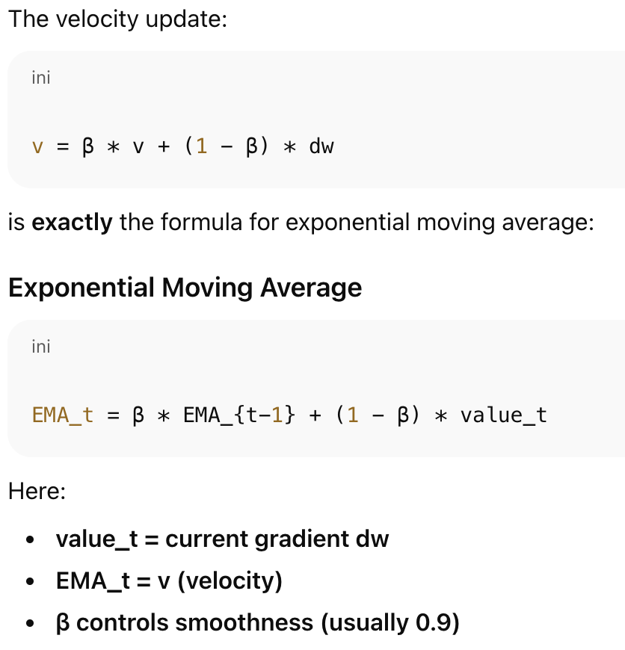

* The idea is that momentum literally keeps an **EMA of all past gradients**, giving more weight to recent gradients. Momentum acts like pushing a ball downhill — it builds speed in the right direction and dampens noise. Why does it help:

1. Faster convergence along consistent directions: if gradients point the same way for many steps: EMA grows 🡪 larger steps 🡪 faster progress
2. Reduced oscillations: if gradients change direction (like in narrow valleys): EMA smooths them 🡪 updates stop zig-zagging.
3. Escapes small local minima: because momentum carries velocity, it can roll past shallow bumps.

* Pseudo code:

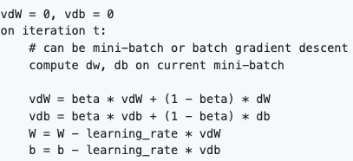

* Momentum parameter, beta = 0.9, and learning rate parameter, alpha = 0.01, are very common and works very well in most cases.
* **momentum doesn’t need bias correction** because the EMA is a helper for smoothing velocity, not for computing a precise normalized update.

## RMSprop (root mean square prop)

* Formula for RMSprop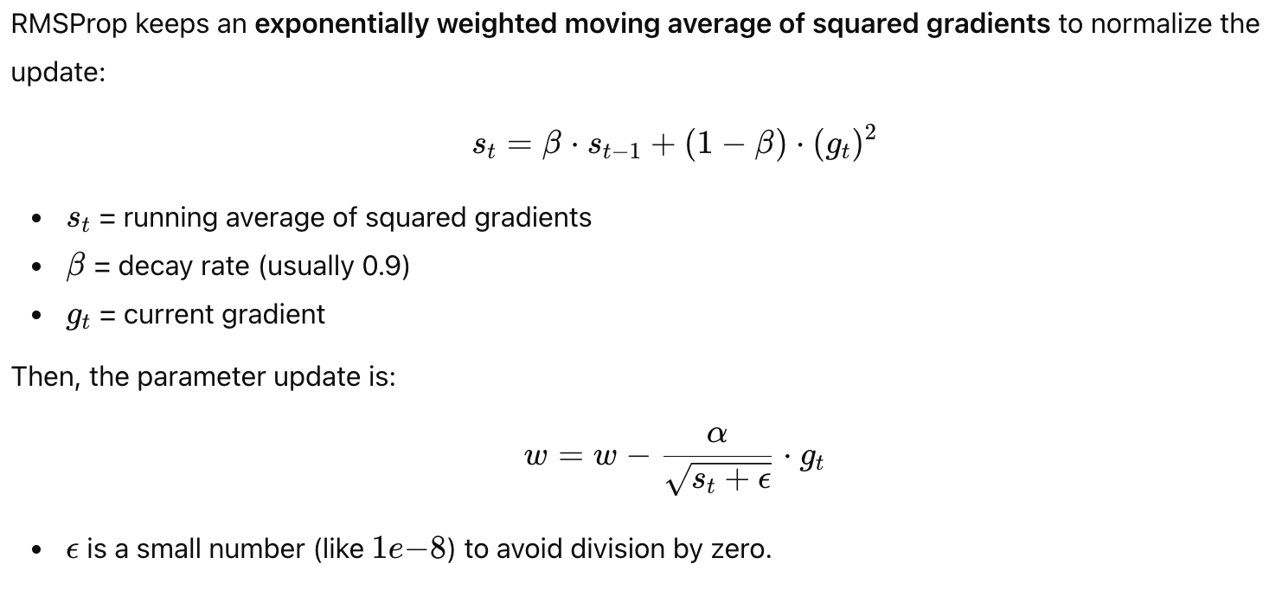
* How it works: RMSProp adapts the step size per parameter. RMSProp scales each update by the **root-mean-square of recent squared gradients**, shrinking steps in steep directions and enlarging steps in flat directions.
* Large gradients → s_t becomes large → effective learning rate 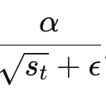 decreases → avoids overshooting.
* Small gradients → s_t is small → effective learning rate  increases → speeds up learning.
* Comparison between momentum (direction smoother) and RMSProp (stepsize scaler)

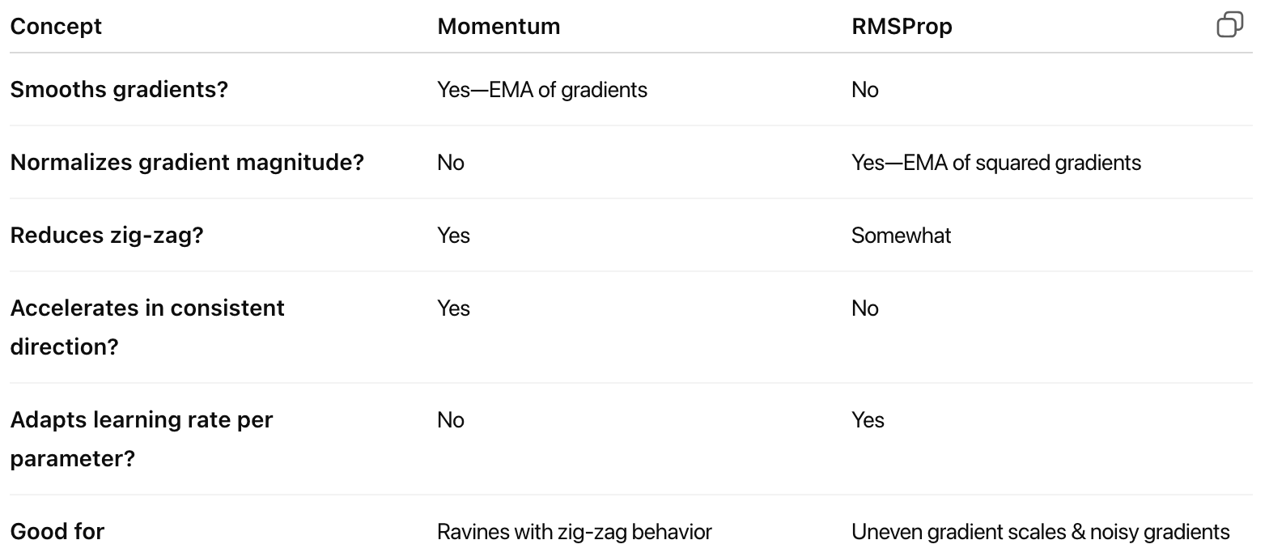

* Pseudo code

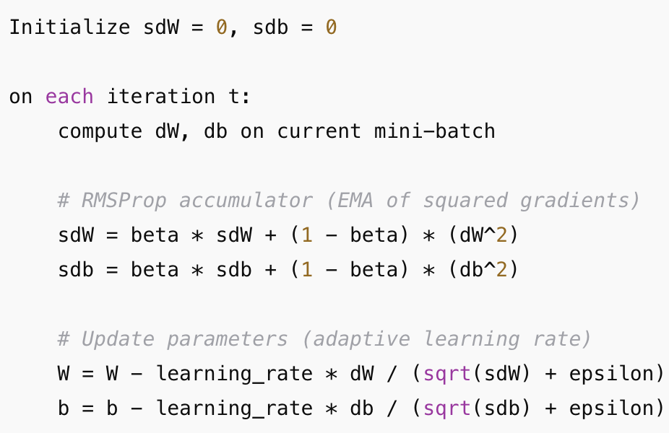

## Adam (adaptive moment estimation) Optimization Algorithm

* Adam update = Momentum (numerator) ÷ RMSProp (denominator)
* Step by step explanation

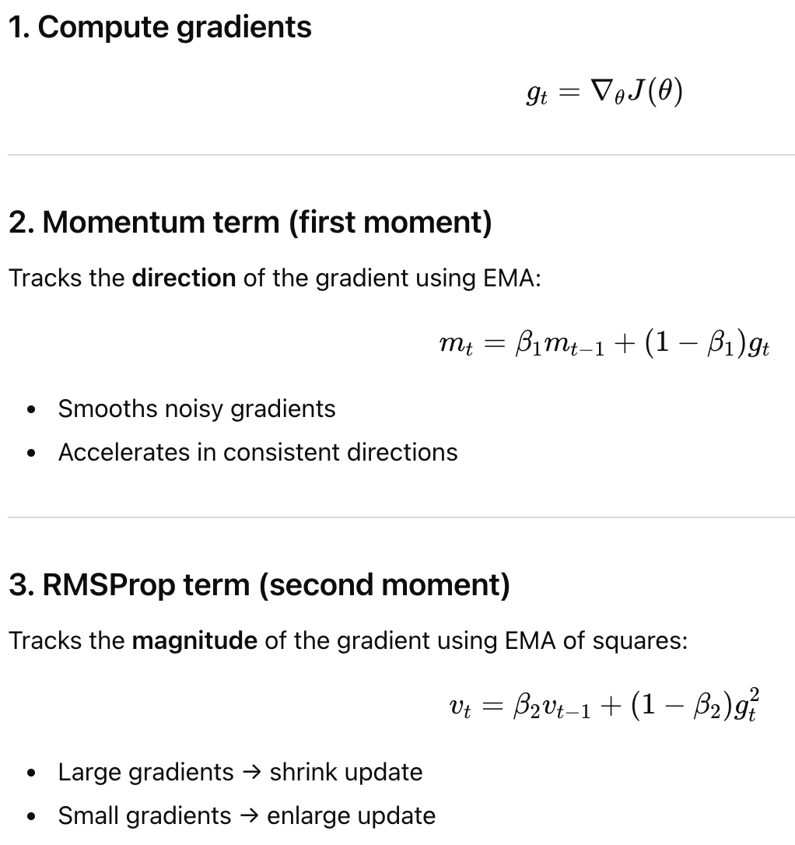

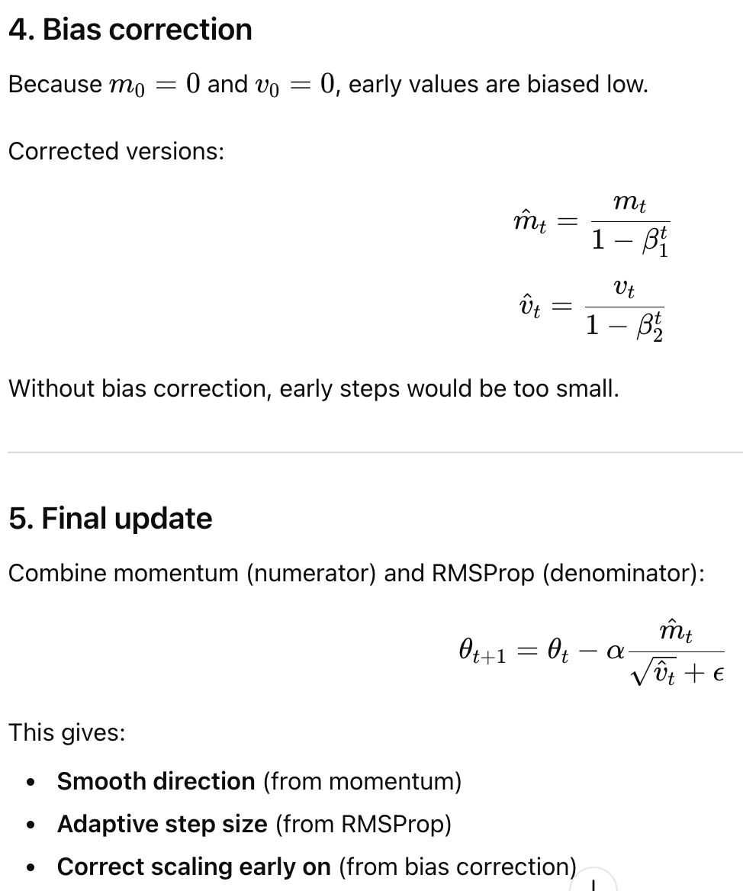

* Psuedo code:

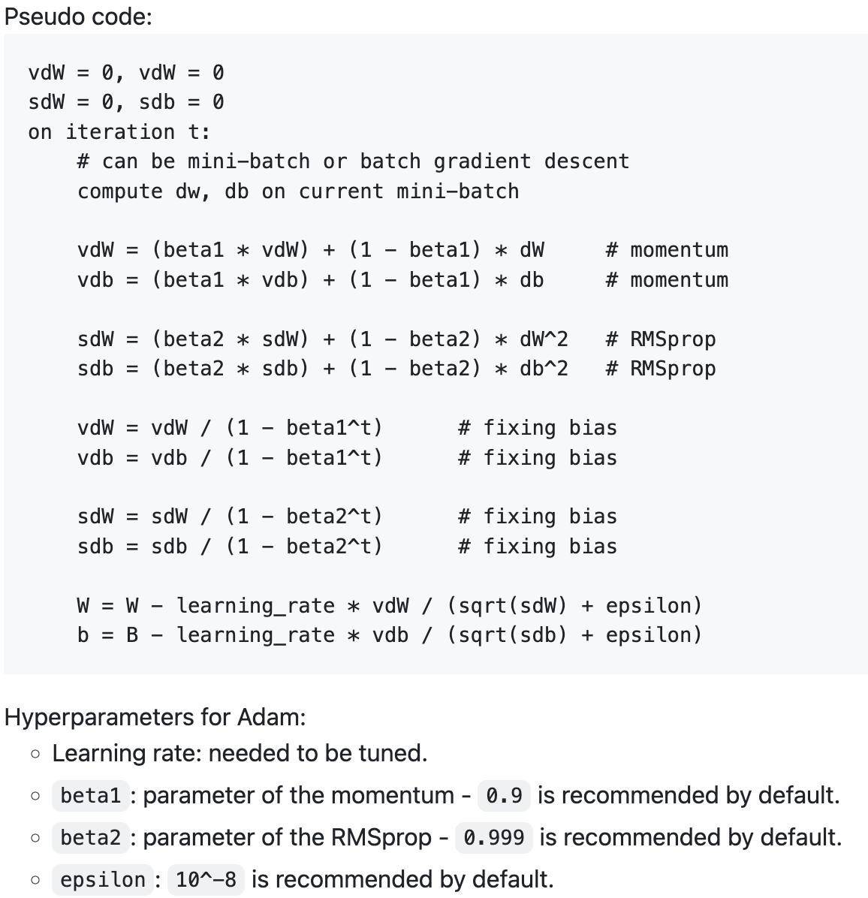

## Learning rate decay

* Learning rate decay (a.k.a. learning rate scheduling): a strategy to reduce the learning rate over time during training. It helps the model converge more smoothly by taking large steps early (to explore the loss landscape) and small steps later (to fine-tune near the optimum).
* Intuition Behind Learning Rate Decay. Think of the optimization as descending into a valley:
  1. At the start (top of the mountain) → you want big steps to get down quickly.
  2. Near the bottom (minimum) → you need small careful steps so you don’t overshoot.
* Common Learning Rate Decay Methods

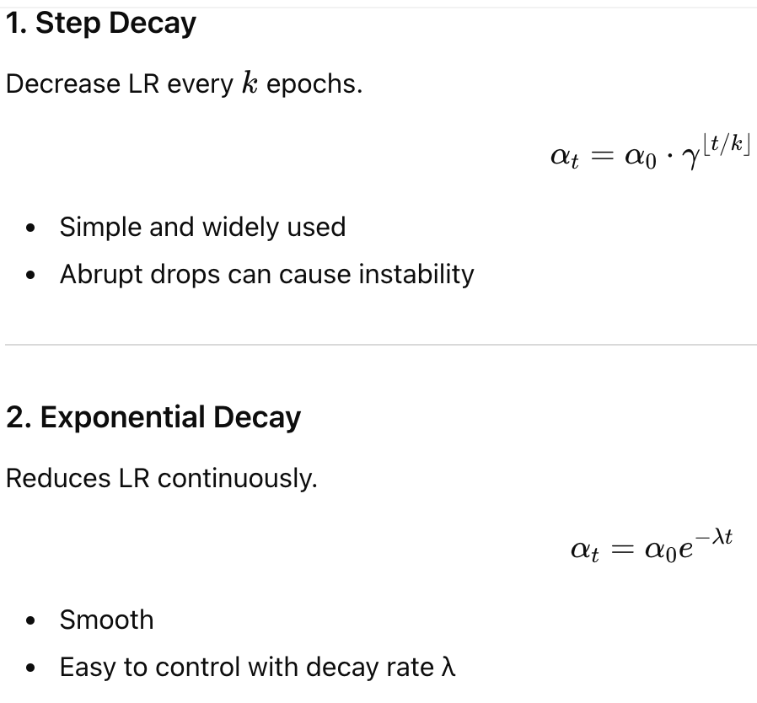

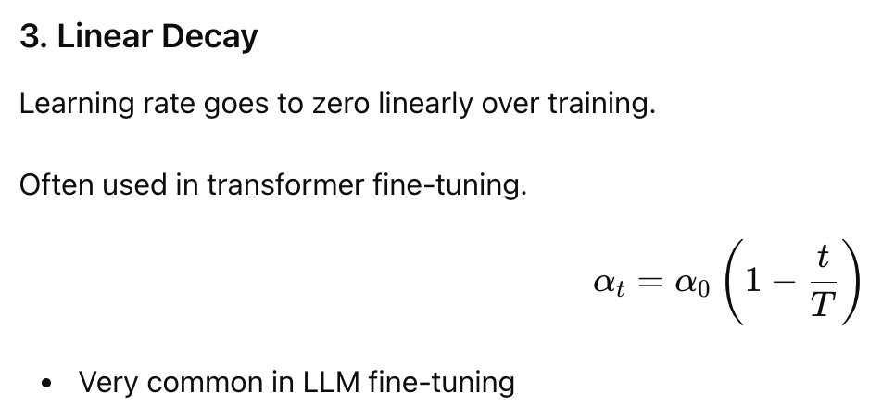

## The problem of local minima

The problem of local optima arises because:

* The loss landscape is non-convex and full of complex structures.
* Gradient descent can get stuck in suboptimal points.
* Saddle points and flat regions slow training enormously.

But optimizers like Momentum, RMSProp, Adam + LR decay mitigate the issue.

# Hyperparameter tuning, Batch Normalization and Programming Frameworks

## Tuning process

To get the best performance from a model, we need to tune its hyperparameters.

Commonly important hyperparameters (per Andrew Ng) include:

* Learning rate (alpha)
* Number of hidden units
* Learning rate decay
* Momentum (β)
* Mini-batch size
* Number of layers
* Regularization parameter (λ)
* Activation functions
* Adam parameters (β₁, β₂, ε)

There is no single “most important” hyperparameter—their impact depends heavily on the specific problem and dataset.

#### Hyperparameter Search Strategies

* **Grid search**: Define a grid of hyperparameter values and evaluate all combinations (simple but inefficient).
* **Random search**: Sample random combinations of hyperparameters; often more effective than grid search.
* **Coarse-to-fine search**:  
  Start with a broad range of values. Once promising regions are identified, zoom in and sample more densely around them.

These tuning methods can be automated using hyperparameter optimization tools.

## Using Appropriate Scales for Hyperparameter Search

When tuning a hyperparameter with a range ([a, b]), it is often better to sample on a **logarithmic scale** rather than a linear scale—especially when values span several orders of magnitude (e.g., learning rate, regularization). Because lots of hyperparameters act multiplicatively, meaning that a 10× change often matters; a +0.01 change often doesn’t.

* Log-scale sampling:

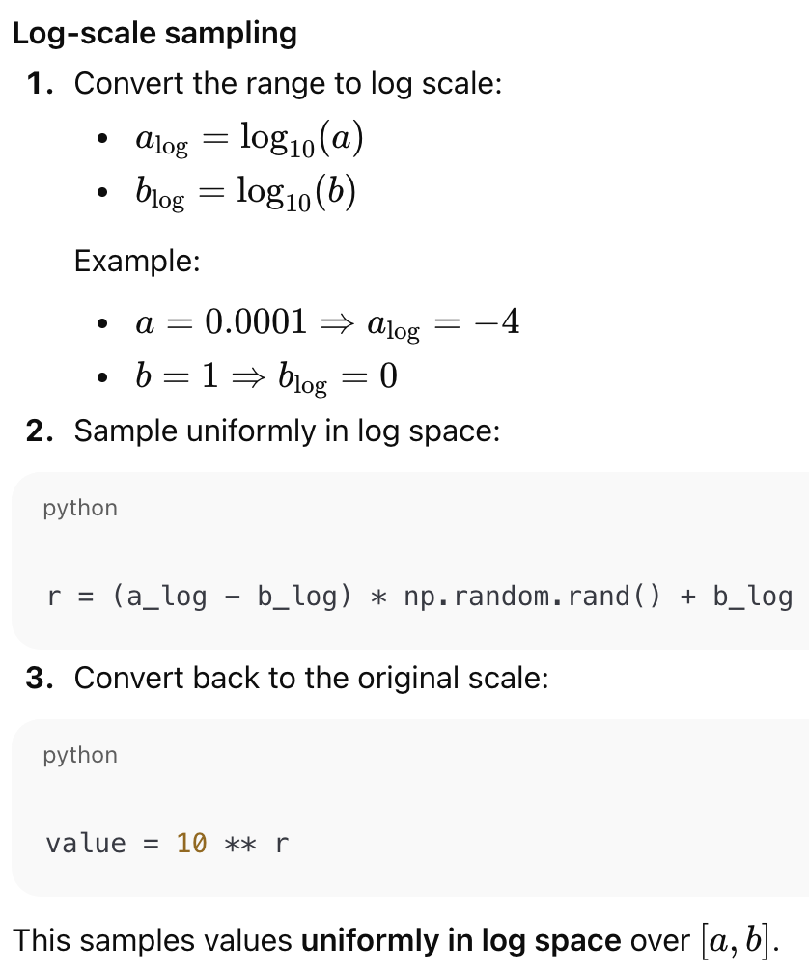

* Example: tuning momentum, beta

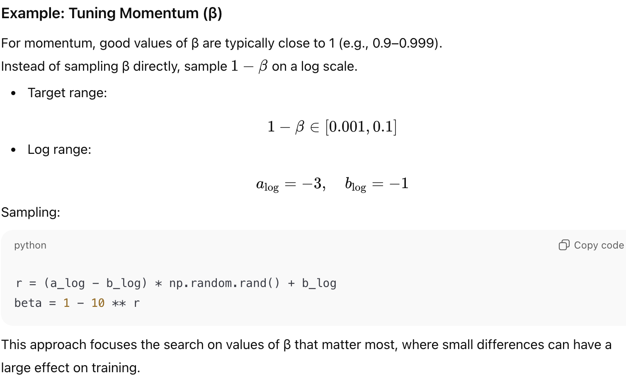

## Hyperparameter Tuning in Practice: Pandas vs. Caviar

Hyperparameter intuition does not always transfer across application domains, so tuning often needs to be problem-specific.

If computational resources are limited, you can use the “**babysitting**” (Panda) approach:

* Start training with randomly initialized hyperparameters.
* Monitor the learning curve as it decreases.
* Gradually adjust hyperparameters during training based on observed behavior.

If computational resources are abundant, you can use the **Caviar** approach:

* Run many models in parallel with different hyperparameter settings.
* Compare results after training and select the best-performing configuration.

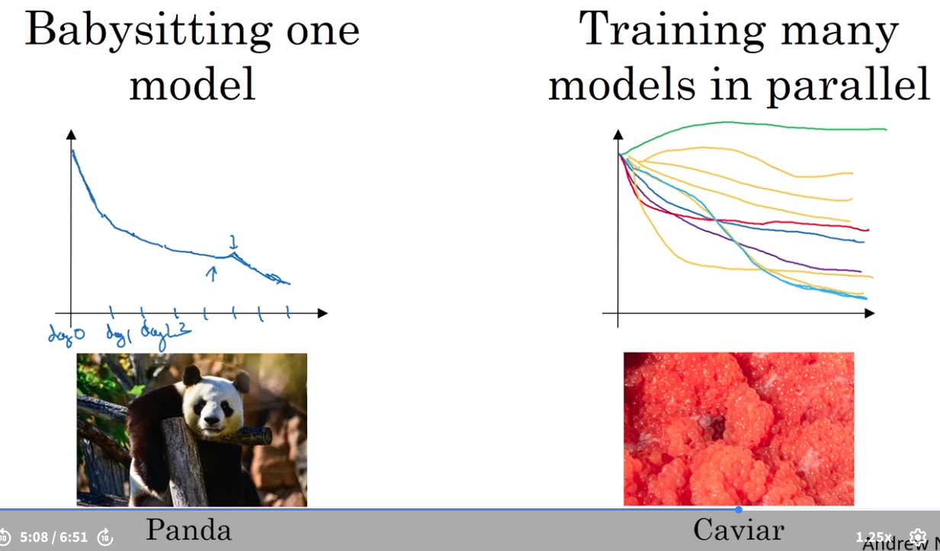

## Batch normalization

Advantage of normalization:

* **Normalizing inputs keeps values on similar scales, so no single feature or neuron dominates the updates, which improves the geometry of the optimization problem.**
* **It prevents extreme activations by keeping pre-activation values near zero, where activation functions are most responsive and do not saturate.**
* **It stabilizes gradients by avoiding very large or very small derivatives, which reduces exploding and vanishing gradient issues.**
* **It reduces shifting input distributions across layers by making each layer see more consistent input statistics as earlier layers change during training.**
* **As a result, training becomes faster and more reliable, allowing larger learning rates, smoother optimization, and more predictable convergence.**

Motivation: Just as normalizing input features improves optimization, we can apply the same idea to hidden layers.

Definition: Batch Normalization normalizes hidden-layer pre-activations  within each mini-batch and then learns a scale and shift, which stabilizes optimization and accelerates training without reducing model capacity.

Batch normalization algorithm (per layer, per mini-batch):

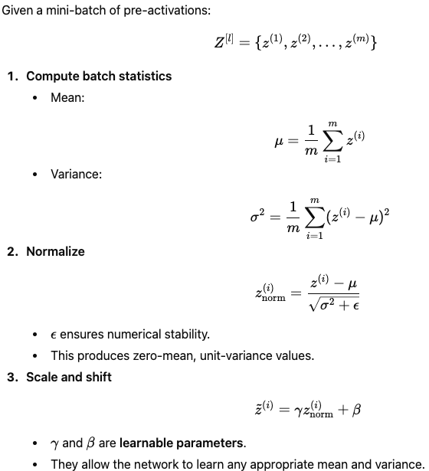

Why $γ$ and $β$ matter:

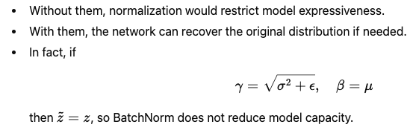

How Batch Normalization Fits into a Neural Network:

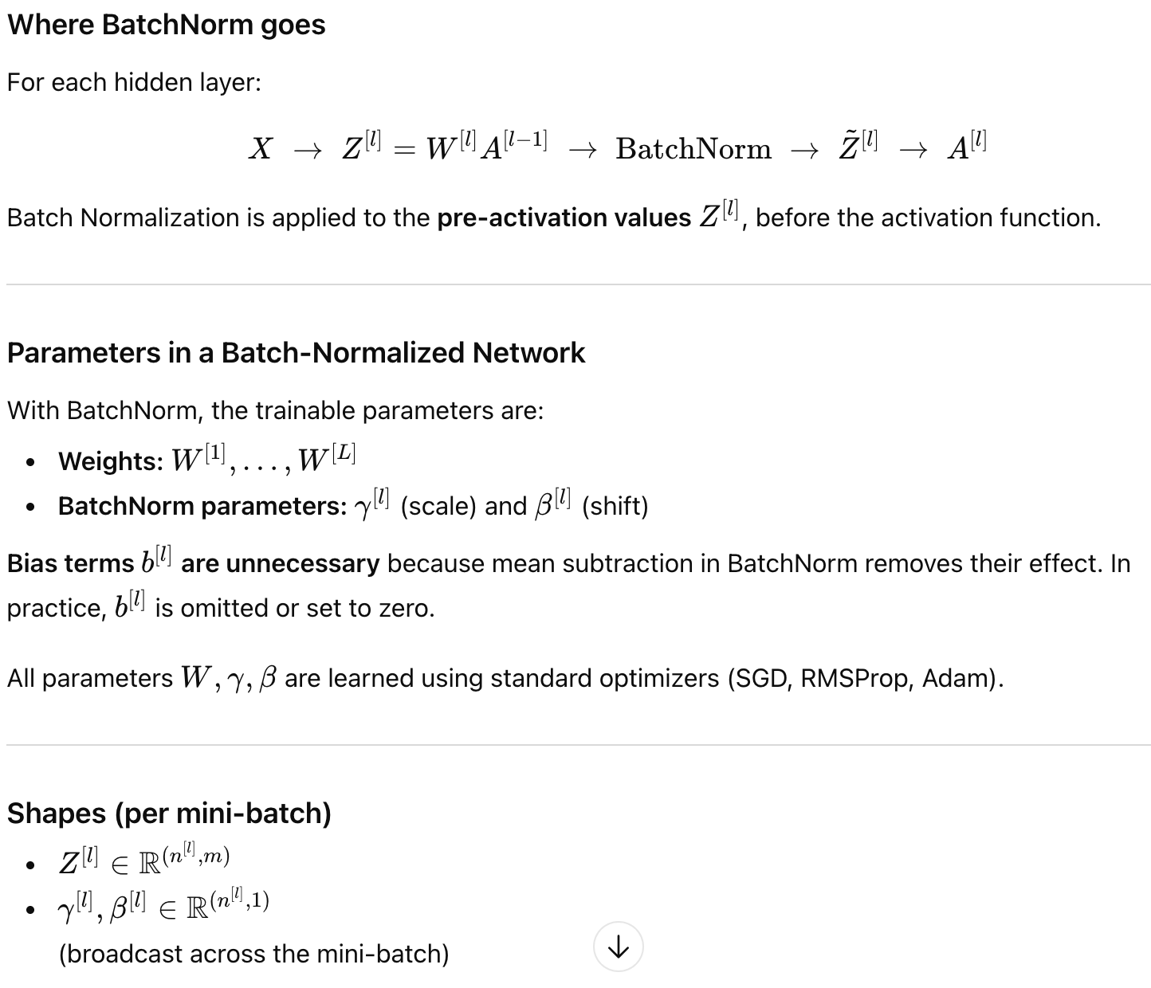

Visualization of the workflow:

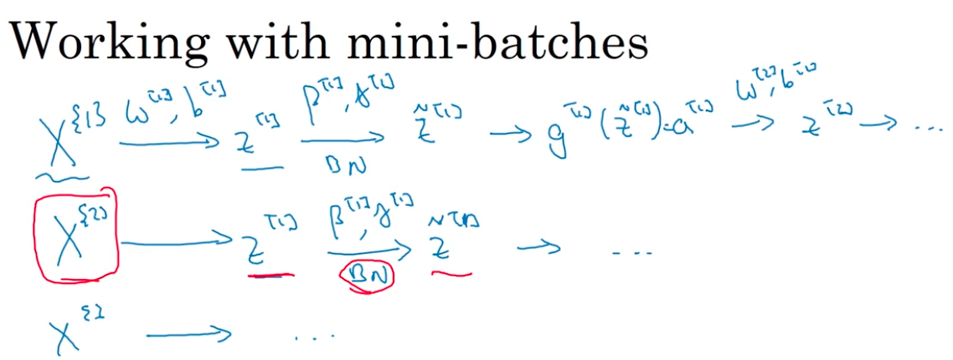

Implementing gradient descent on batch norms:

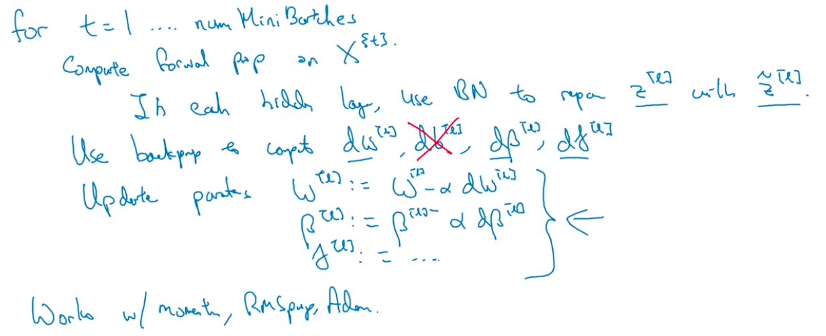

Why Batch Normalization Works:

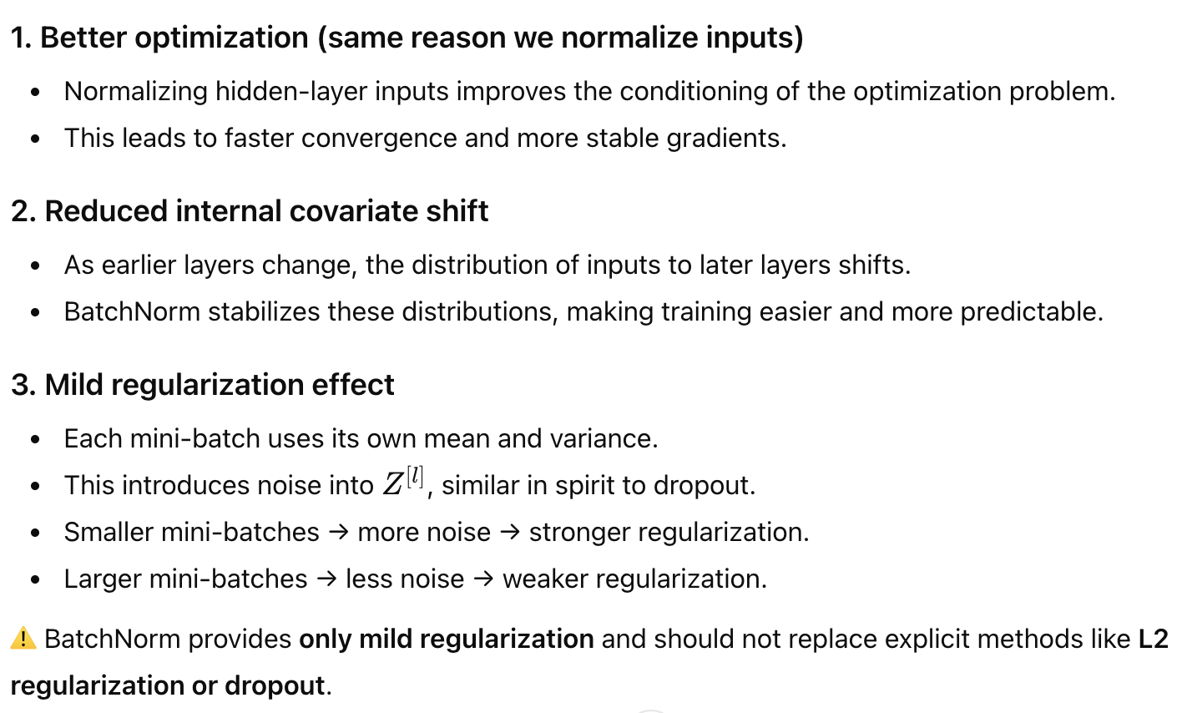

Batch Normalization at Test Time:

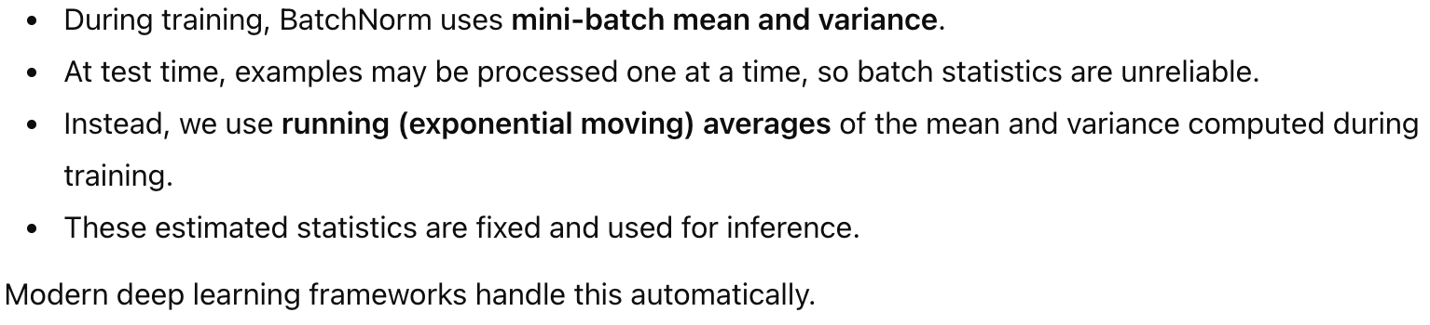

## Softmax Regression

**Definition:**

**Softmax regression** is a generalization of logistic regression used for **multiclass classification.**

Example:

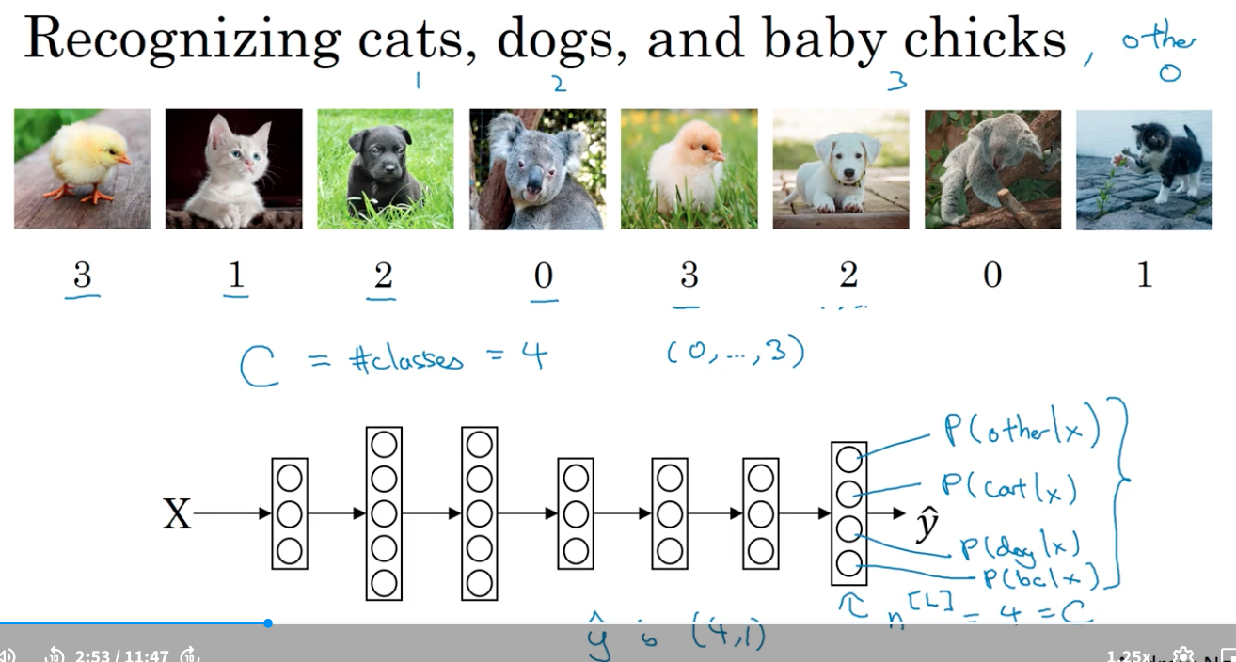

Softmax activation function:

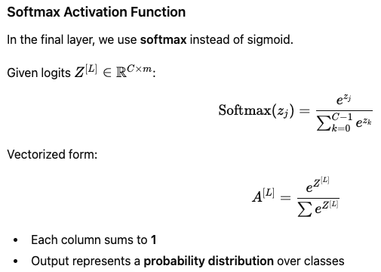

Loss function & cost function of softmax:

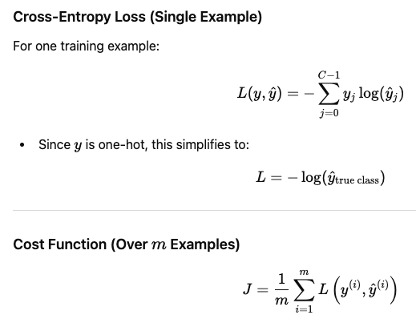

Backpropagation:

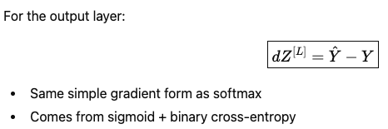

Prediction:

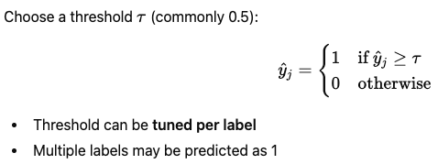

## Deeplearning framework

Deeplearning frameworks and criteria to choose framework:

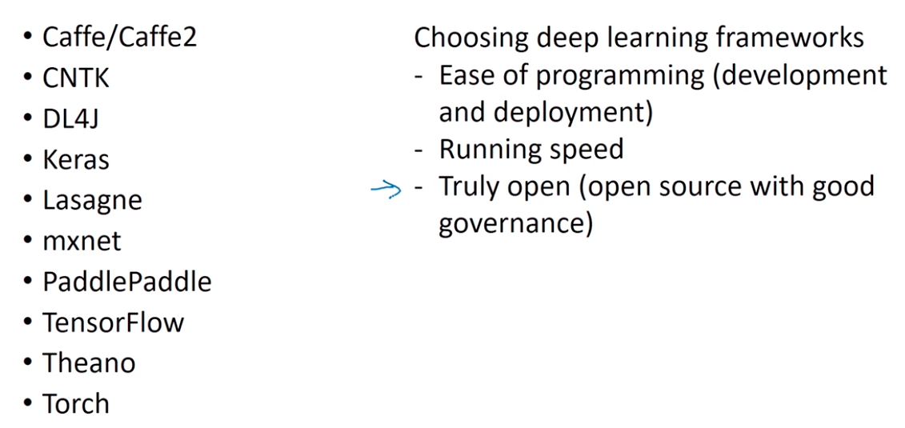

Comparison between frameworks:

<https://en.wikipedia.org/wiki/Comparison_of_deep_learning_software>

## Tensorflow

Problem to solve:

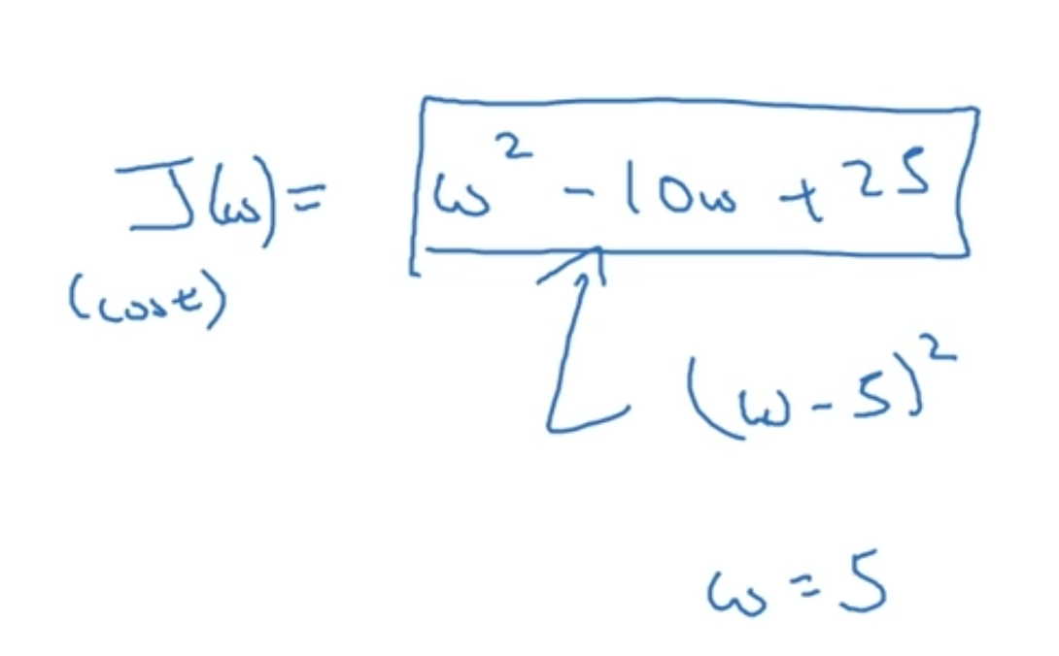

How to solve it using Tensorflow:

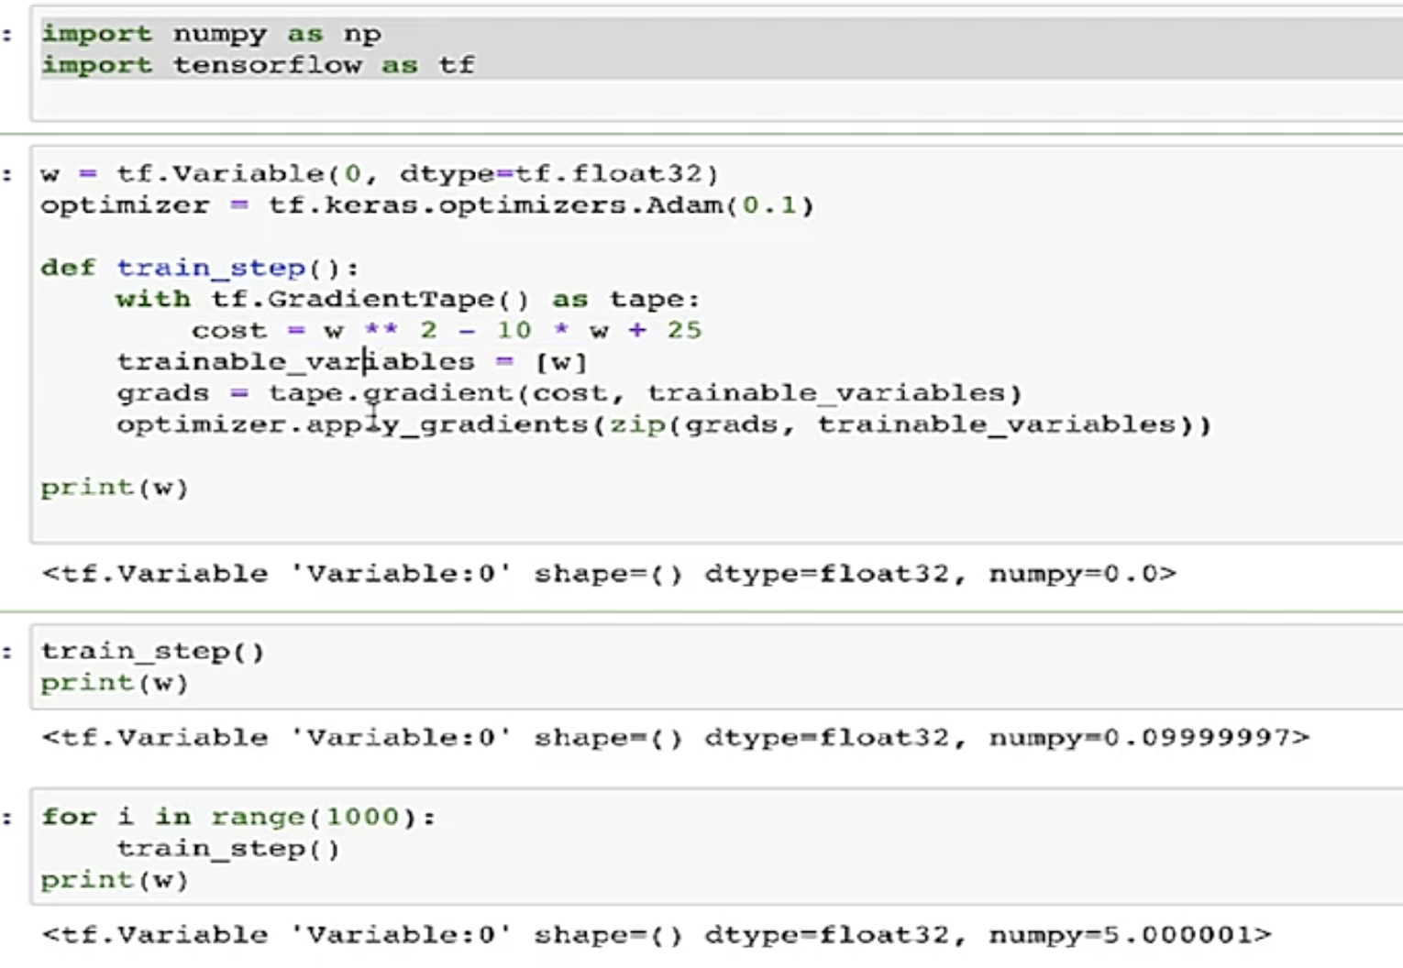

Tensorflow did the backward propagation automatically:

